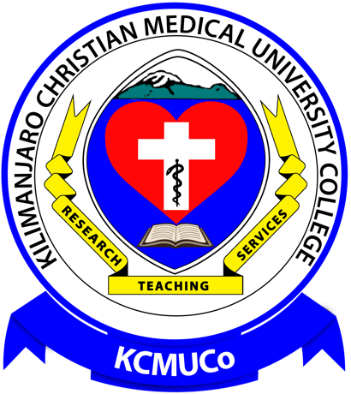

KILIMANJARO CHRISTIAN MEDICAL UNIVERSITY COLLEGE
(A Constituent College of Tumaini University Makumira)

P. O. Box 2240, MOSHI, Telephone 255-027-2753616.
Tanzania. Fax: 255-55-2751351.
Email: info@kcmuco.ac.tz Web site: http://www.kcmuco.ac.tz
21th March 2023
ZGT-Overzee
Hengelo
The Netherlands

Dear Dr. Said Salah,

RE: APPRECIATION FOR EQUIPMENT DONATION

On behalf of the Kilimanjaro Christian Medical University College (KCMUCo), we would like to thank ZGT-Overzee for the very generous donation and shipment of the equipment for our Biochemistry, Molecular Biology and Physiology practicals.
We gratefully acknowledge the receipt of the following devices: 1 Centrifuge, 2 Multiscan microplate readers, 1 Water bath, 1 Thermoshaker, 3 Bicycle exercise ergometers, 2 Beamers, 1 Automatic blood pressure monitor and 1 Visual adjustment set. All the goods have arrived in excellent shape.
Just to give you an idea about the impact of this donation, our Departments organise various courses for approximately 200 MD students, 130 Specialists in training, 100 BSc Health Laboratory Sciences students, 50 BSc Physiotherapy and 50 BSc Nursing, i.e. annually 530 students in total.
Below please find two photographs, one taken in our Physiology practical room, featuring prominently in the front the bicycle exercise ergometers, and the very happy staff from the Physiology department in the back; and another one taken in our Molecular Biology laboratory with Prof Kavishe and staff of the lab receiving the equipment.
Thank you very much for your donation!

With warm regards,
Professor Ger Stienen Professor Reginald Kavishe
Chair Dept of Physiology, KCMUCo Chair Dept of Biochemistry, KCMUCo
Em. Prof. VU, Amsterdam

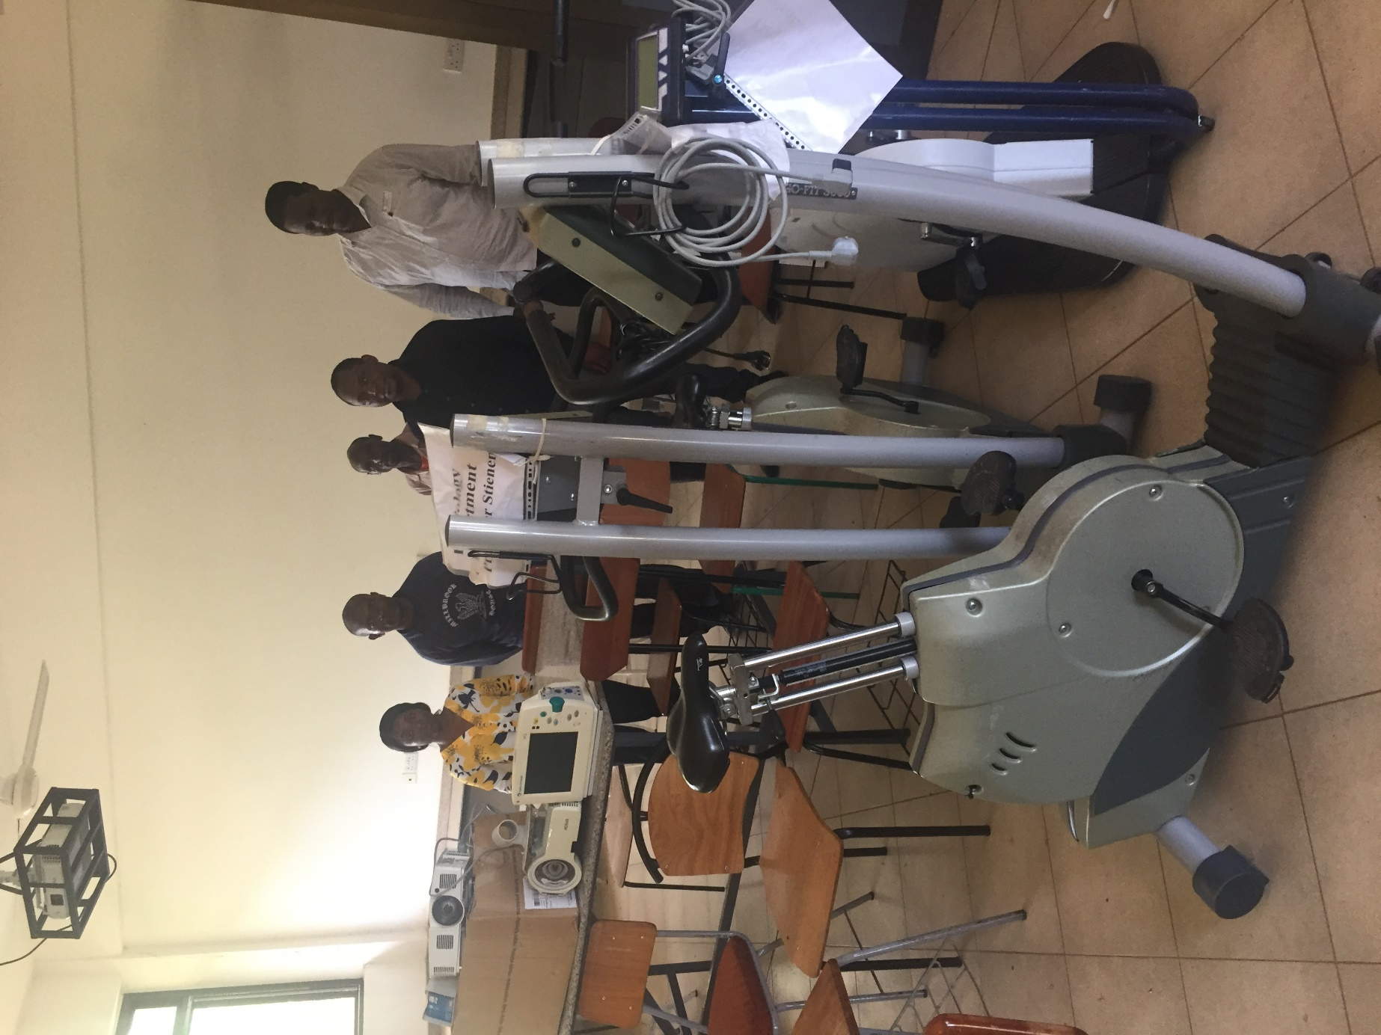

Department of Physiology, February 13, 2023

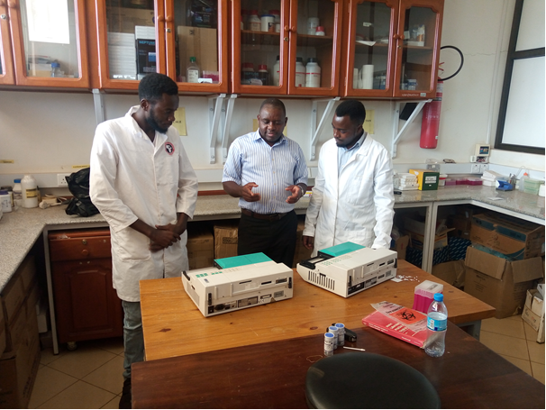
Department of Biochemistry and Molecular Biology. Prof. Reginald Kavishe (center) and staff of the Lab receiving the equipment.

